Module 3: IBM Python Assignment

1. Consider a list (list=[]) and perform insertion, print, remove, append, sort, pop, reverse.

**Solution:**

N = int(input())

lst = []

for i in range(0,N):

s = input().split()

if s[0] == "append":

lst.append( int(s[1]) )

elif s[0] == "insert":

lst.insert(int(s[1]) , int(s[2]))

elif s[0] == "remove":

lst.remove(int(s[1]))

elif s[0] == "pop":

lst.pop()

elif s[0] == "index":

lst.index(int(s[1]))

elif s[0] == "count":

lst.count(int(s[1]))

elif s[0] == "sort":

lst.sort()

elif s[0] == "reverse":

lst.reverse()

elif s[0] == "print":

print(lst)

**Output:**

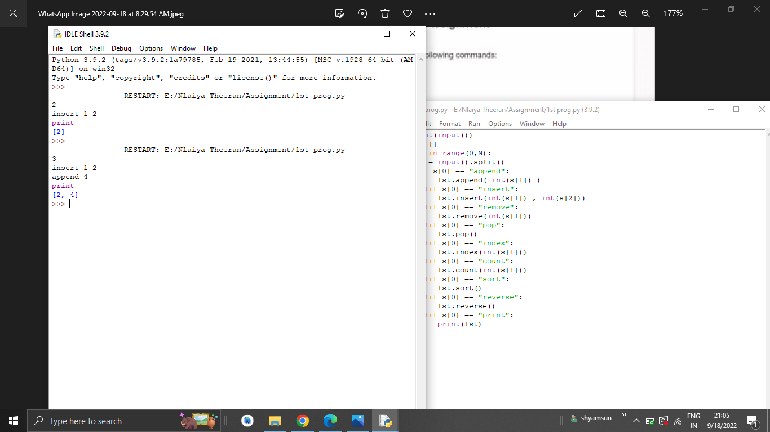

1. Write a calculator program in python.

**Solution:**

def add(P, Q):

return P + Q

def subtract(P, Q):

return P - Q

def multiply(P, Q):

return P * Q

def divide(P, Q):

return P / Q

print ("Please select the operation.")

print ("a. Add")

print ("b. Subtract")

print ("c. Multiply")

print ("d. Divide")

choice = input("Please enter choice (a/ b/ c/ d): ")

num_1 = int (input ("Please enter the first number: "))

num_2 = int (input ("Please enter the second number: "))

if choice == 'a':

print (num_1, " + ", num_2, " = ", add(num_1, num_2))

elif choice == 'b':

print (num_1, " - ", num_2, " = ", subtract(num_1, num_2))

elif choice == 'c':

print (num_1, " * ", num_2, " = ", multiply(num_1, num_2))

elif choice == 'd':

print (num_1, " / ", num_2, " = ", divide(num_1, num_2))

else:

print ("This is an invalid input")

**Output:**

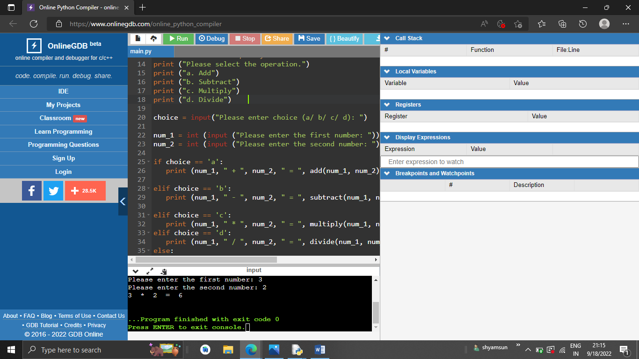

1. Write a program to concatenate, reverse and slice a string.

var1 = "Hello "

var2 = "World"

var3 = var1 + var2

print(var3)

txt = "Hello World"[::-1]

print(txt)

b = "Hello, World!"

print(b[2:5])

**Output:**

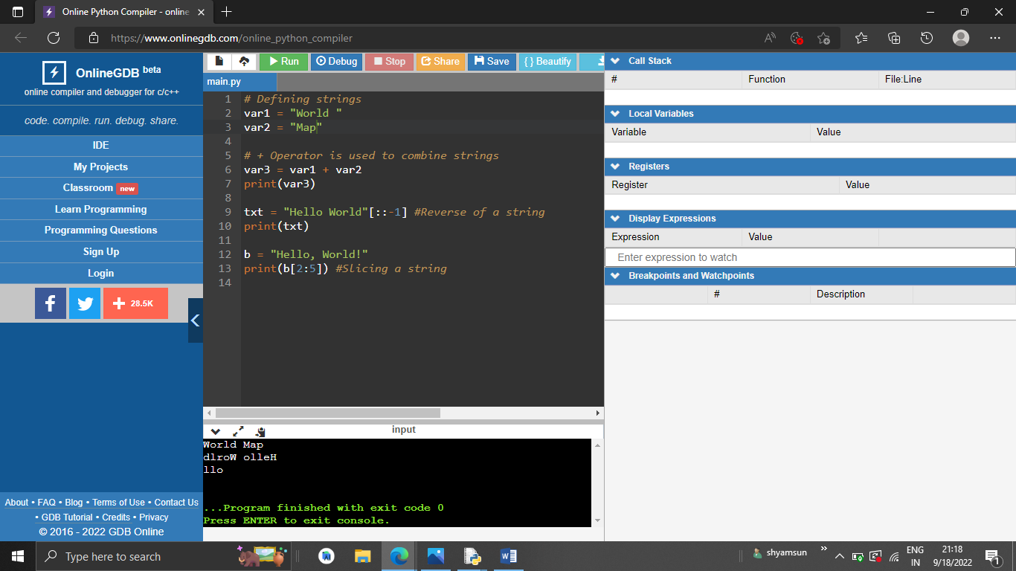

1. Why is a python a popular programming language?

* Python is an interpreted, object-oriented, high-level programming language with dynamic semantics.
* Python's simple, easy to learn syntax emphasizes readability and therefore reduces the cost of program maintenance.
* Its design philosophy emphasizes code readability with the use of significant indentation. Python is dynamically-typed and garbage-collected. It supports multiple programming paradigms, including structured, object-oriented and functional programming

1. What are the other frameworks that can be used with Python?

* Django
* Flask
* AIOHTTP
* Bottle
* Dash
* Falcon

1. Full Form of WSGI?

* WSGI Stands for Web Server Gateway Interface
* **WSGI**is a specification that describes the communication between **web servers and Python web applications or frameworks**.
* It explains how a web server communicates with python web applications/frameworks and how web applications/frameworks can be chained for processing a request.